**Shutter Plug Final Report**

**Georgia Gwinnett College**

**ITEC 3870 - Software Development II**

**Fall 2019**

Table of Contents

Feature Overview 3

Implemented Features 3

Remaining Features 4

Known Issues 5

Client’s Biography, Vision, and Story 6

Why Shutter Plug? 7

Project Flyer 8

Demonstration Video 9

Team Members 9

Testing Coverage, Methods, and Results 10

Intellectual Property Agreement 21

Installation, User, and Development Documentation 25

Development Information 26

Usability Testing / Focus Group Survey Results 27

# Feature Overview

## Implemented Features

* Home Page / Landing Page
* Small blurb
* Photos (provided by client)
* Navigation Bar
* Dashboard Link (when logged in)
* “Search for an Artist” Link
* Sign Up/Log In/Log Out Links
* Register and Login (with Authentication)
* Profile Creation/Editing (for Artists only)
* Dashboard for users
* Create Profile
* Can upload profile pic
* Can add social media links
* Can provide profile details such as name, location, and qualifications
* Edit Profile
* Browse an Artist
* Default view shows all profiles
* Search by Parameters
* First and Last Name
* Specializations
* Certification
* Results displayed in vertical alignment
* Cloud storage for user data using MongoDB
* Data Models/Schemas defined using Mongoose
* User
* Profile
* Posts (not used in this implementation)
* API routes
* Both public and private
* Responsible for data manipulation in database
* **api/users:** Create user, login**, view current user**
* **api/profile:** Get current profile**, get all profiles, search profile, get profile by ID, create or edit existing profile**, delete profile**
* **api/posts:**Create post**, get all posts, get post by ID, delete post by ID**, like / unlike post**, comment on post**, delete comment from post**

** -> Authenticated routes

## Remaining Features

* Navigation Bar
* Contact Us Link
* About Us Link
* Additional Search Parameters:
* Location (possibly use a third-party package)
* Experience
* Additional Artist profile features
* Implementation of artist portfolio, either through manual upload or Instagram API call
* Comment and Like/Unlike feature of Artist profiles
* Implementing other user types:
* Admin
* Admin dashboard:
* Artist profile approval and editing
* Employee access creation
* Business submission approvals
* Featured Artist/Promo ability
* Client
* Ability to comment and Like/Unlike artist profile
* Favorite artist
* Employee
* Employee dashboard
* Artist profile approval and editing
* Business submission approvals
* Featured Artist/Promo ability
* Business
* Business dashboard
* Can submit ads or promotions
* Enhanced Password features
* Password reset and recovery
* Stricter password requirements (characters restrictions)
* Artist profile tweaks:
* “To Be Approved” collection
* “Approved” collection
* “Deleted” collection

## Known Issues

* “Edit User” Bug:
* **Problem:**If you create a profile and attempt to edit it, the “Specializations, Certifications, and Distance” dropdowns do not re-populate
* **Temporary solution:** Force users to re-select these values when they edit a profile
* Search Blank Arrays:
* **Problem:**An artist with a blank array for either “Specializations” or “Certification” will not be returned as a matching artist when searching, even for the default view of all artists. This is due to how the Mongoose search method of ‘.in’ looks through the array for a match to the array passed in as a parameter.
* **Temporary solution:** Input at least one selection for both arrays for test user info
* Default Image
* **Problem:**Default image is not populating during “Create Profile”

# Client’s Biography, Vision, and Story



Christy’s Story:

My name is Christy Conners, I am a mother, an artist, a teacher, and a problem solver.

Since 2005 I have been a teacher for Gwinnett County Public Schools, currently teaching at Grayson Technical High School as a Commercial Photography Instructor. The program has grown from about 20 students to 70 students over the past three years.

And year after year I have been faced with the same question by my graduating classes,

“Now what do we do with our photography? How are we supposed to find jobs without the help of Grayson Tech?”

I taught them how to create contracts, secure internships, make websites, and self- promote, but how do they connect to potential clients now that they are no longer my students?

Shutter Plug was born:

It was from the frustrations of my young entrepreneurs and my desperate need to help them as they began their journey after High School that Shutter Plug was born. Not just to help my former students, but to help everyone in the community that was constantly coming to me for photographers and didn’t know where to find them.

I have been approached by: fashion designers, Etsy shop owners, motivational speakers, sports organizations, PTSA Presidents, salon owners, makeup artists, automotive detailers, restaurants, bakeries, interior designers, real estate businesses, music producers, publicists, and so many more individuals that are in need of talented photographers.

Shutter Plug can help all these people connect and create a community of collaboration that Atlanta and the metro area needs!

## Why Shutter Plug?

In the past, photographers have had to rely on word of mouth and paid advertisements in local publications. Most of the larger more known companies had monopolies over the market in their community. In this new era of technology and social media, photographers have a leg up in this new market and can use Apps like Instagram and Facebook to launch their business, advertise, and gain exposure.

There are several Apps out there that help Photographers book jobs, but they have limited advertising and they also take a fluctuating percentage of each job booked through their App. Shutter Plug is different from these Apps because we do not make money off of jobs or handle the money exchanges between the photographer and the client. We are about helping people connect, we create the PLUG for businesses and photographers in the community to join forces and support each other. With the creation of Shutter Plug we can put more community photographers on the map therefore creating more competition in the marketplace.

An average shoot in our community costs upwards of $400 for one hour. Parents are paying over $50 twice a year for a one pose photo of their child with horrible dated backdrops and over edited prints provided by the overpriced out dated companies. We live in a community that needs more diverse photo competition to help balance the big companies that have contracts with all the schools, sports organizations, and cooperate businesses.

Shutter Plug can help lead our communities toward an easier, cost effective, and more efficient way to collaborate with photographers and videographers in the same area. Together with Shutter Plug we can grow local businesses and create a higher level of community interaction.

# Project Flyer



# Demonstration Video

**https://youtu.be/BXEuS-EflOk**

# Team Members

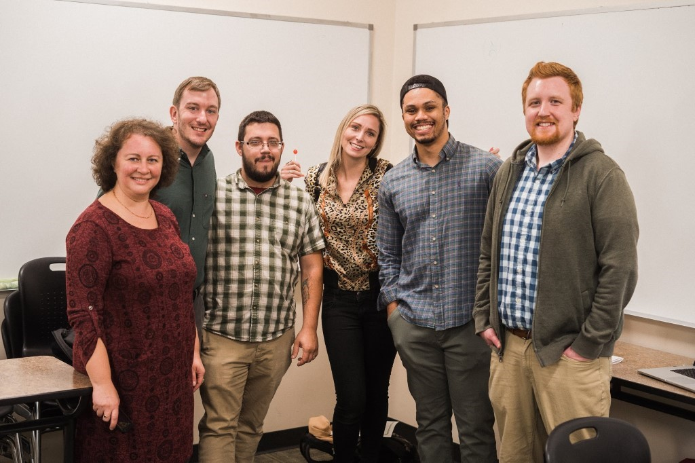*Listed below from left-to-right:*

* **Dr. Anca Doloc-Mihu (Professor)**
* **Ryan Cunico**
* Lead Programmer
* Client Liaison
* **Rodney Brown**
* UI/UX Designer
* Lead Tester
* **Christy Conners (Client)**
* **Malik Norford**
* Project Manager
* Data Modeler
* **Richard Smith**
* Lead Programmer
* Documentation Lead

# Testing Coverage, Methods, and Results

*Testing Coverage:*Testing for Shutter Plug was done using Postman and by using a development mode using REACT via npm run dev. The following steps are required to begin testing API calls and the Shutter Plug app.

1. Install Postman via the weblink https://www.getpostman.com/downloads/ and choose the download that fits your computer. 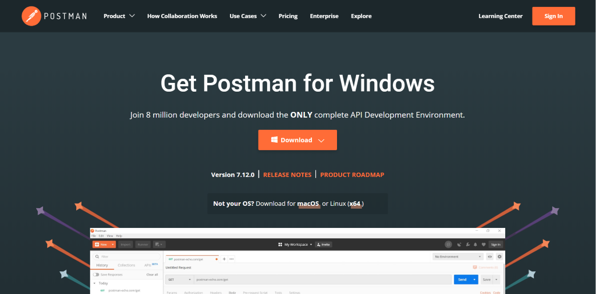

1. If the user is using Visual Studio Code after installing all necessary, inside the terminal input **npm run dev** to begin running a development instance of the application and press enter. 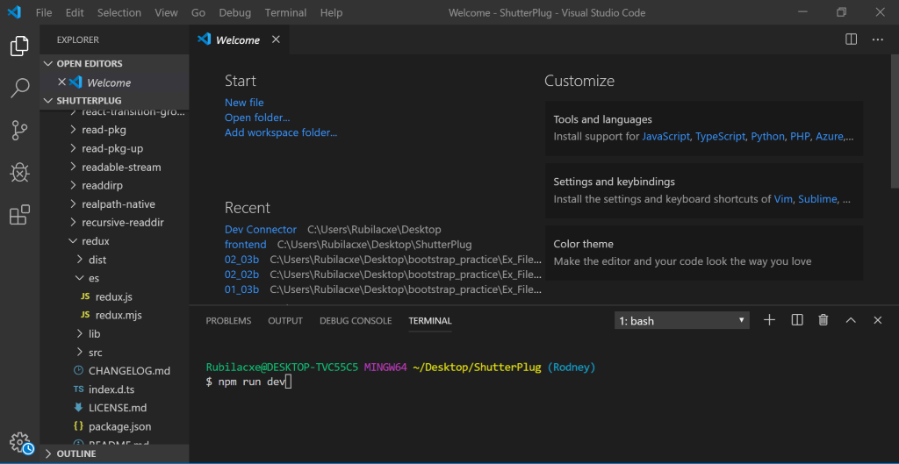

*Testing Methods:*Once you have the environment up and running and have a connection to Mongo DB, you are ready to begin testing.

1. Launch Postman and on the main screen under my workspace, press on the plus symbol to begin testing API routes. 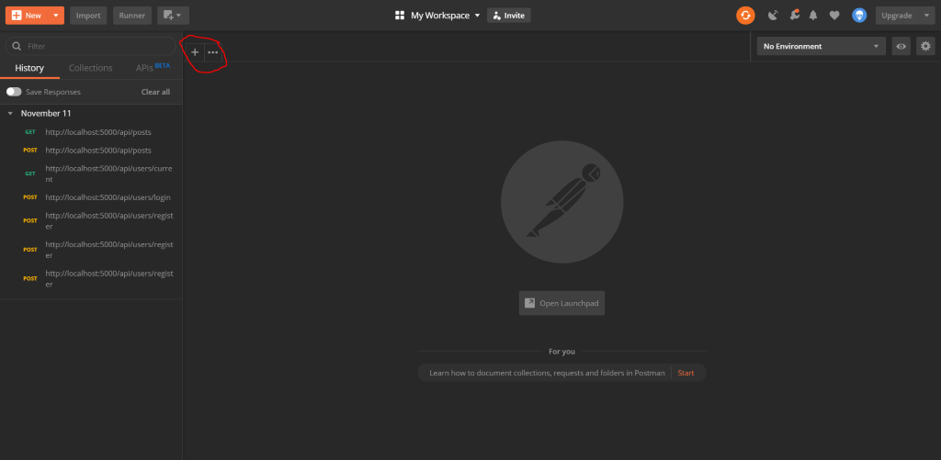
2. API routes can be found in the doc folder of the GitHub Repo as well as parameters to test the calls.

1. Calls to Mongo DB can be made using http://localhost:5000/ followed by the api route to be testing and which method is being tested (GET, POST, DELETE, etc…). Below is an example of the results. Red = method, Black = API route, Blue = results. 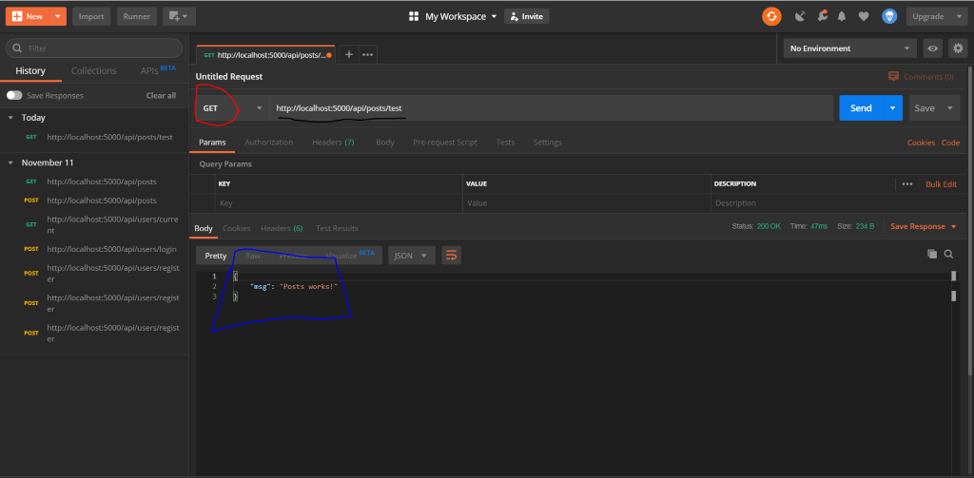
2. Many routes require authorization, authorization must be completed inside of the header tab in order to send information to the route and data sent to fields in Mongo DB must be entered (case sensitively) inside of the body tab. To access the Bearer token required to gain authorization. You must use the route listed below a current user login inside of the body tab. This will return the bearer token required for authorization.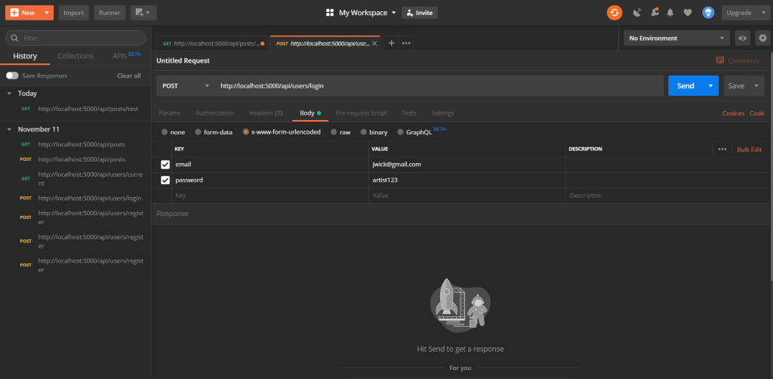

1. Happy Testing!

*Testing Results:*Below are test results to different API routes used in the development of the Shutter Plug App.

**api/users/test (GET)**

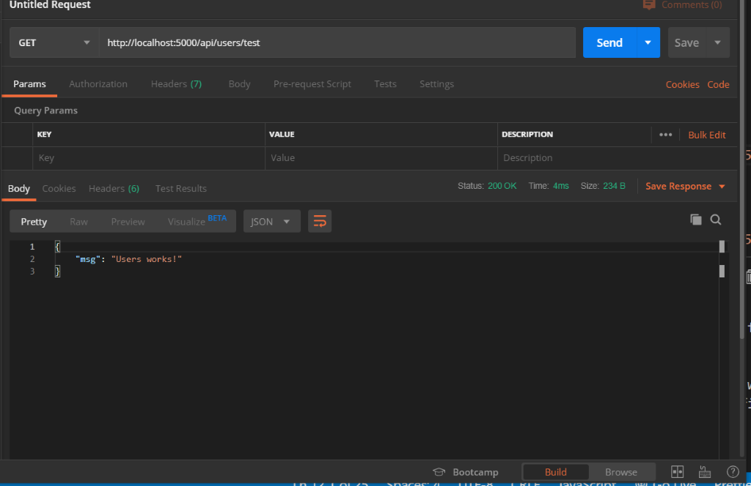

**api/users/register (POST)**

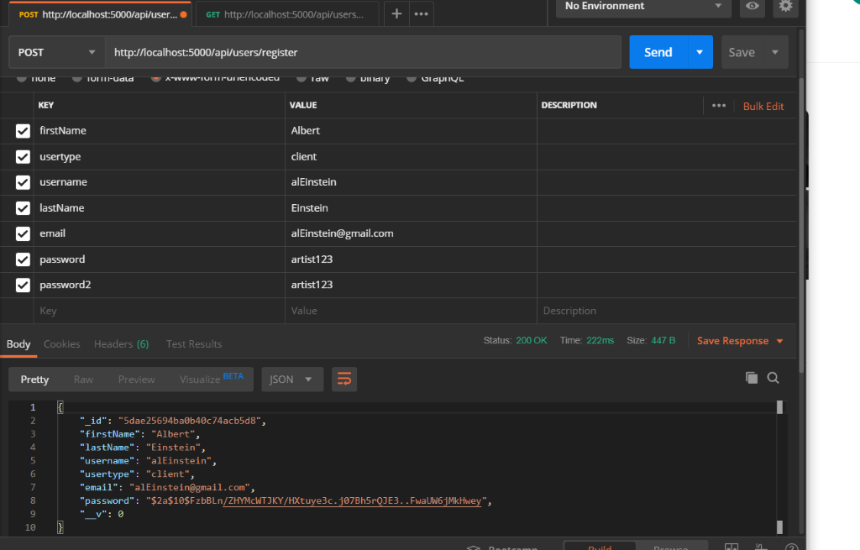

**api/users/login (POST)**

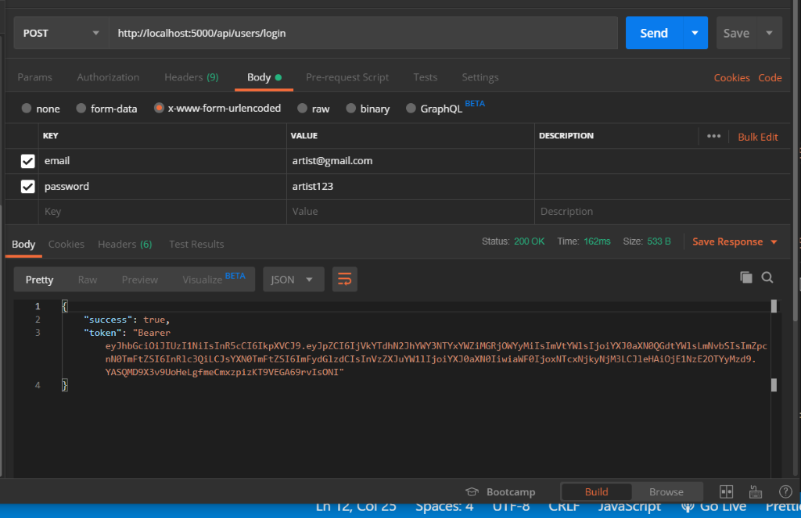

**api/users/current (GET)**

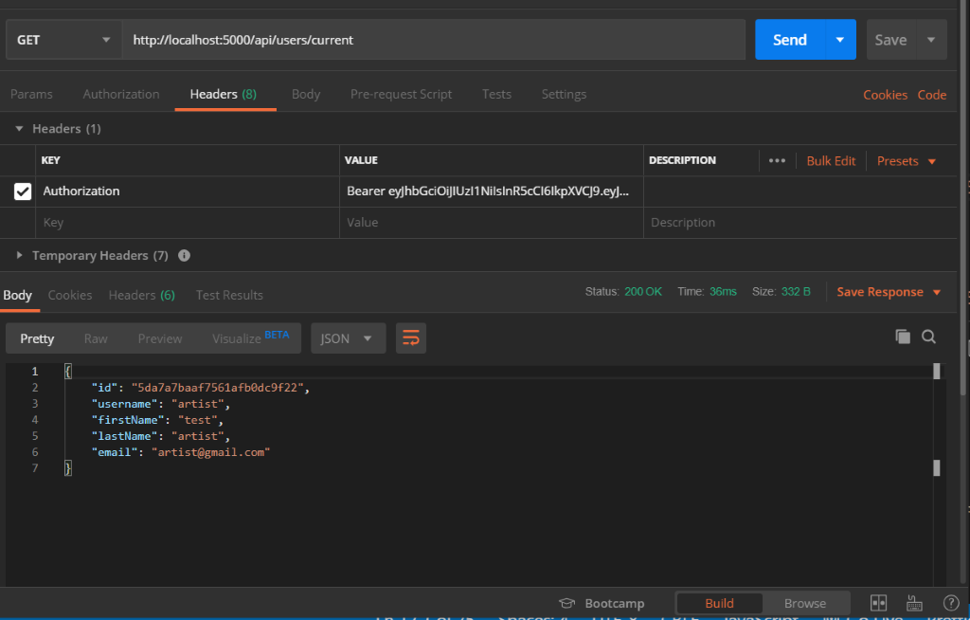

**api/profile/test (GET)**

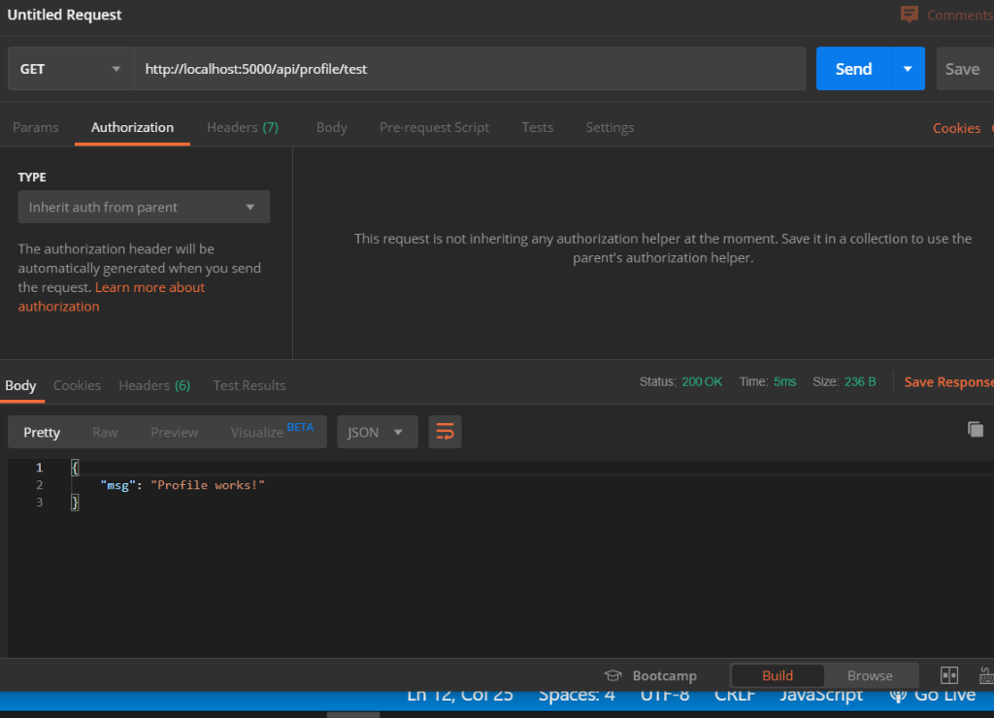

**api/profile (POST)**

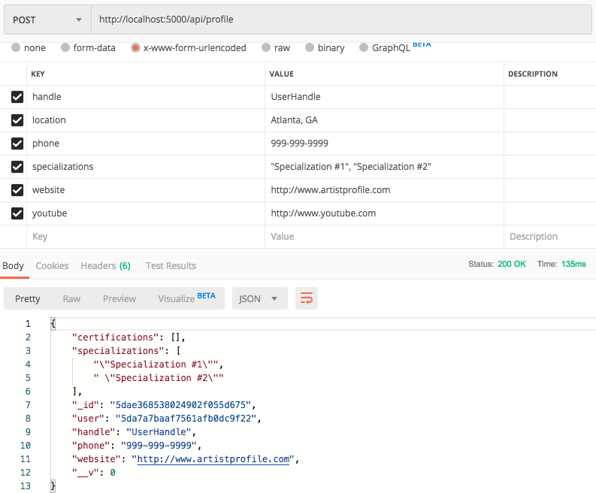

**api/profile/all (GET)**

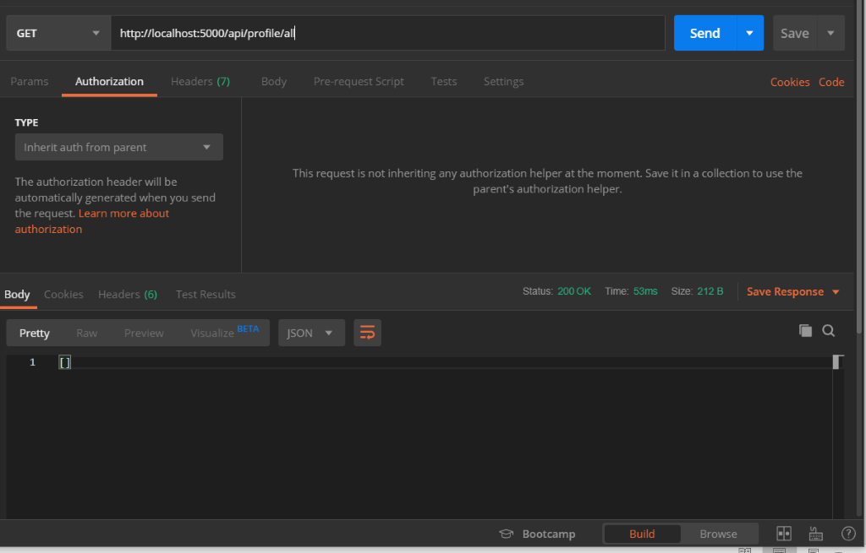

**api/posts/unlike/id (POST)**

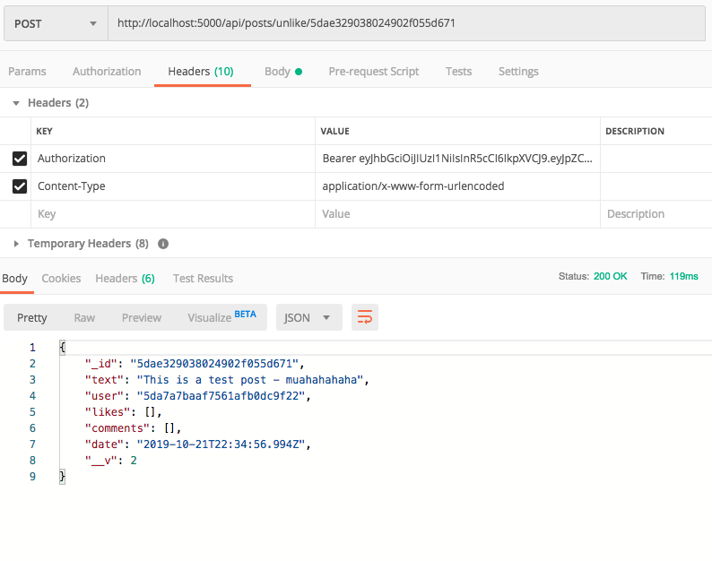

**api/posts/test**

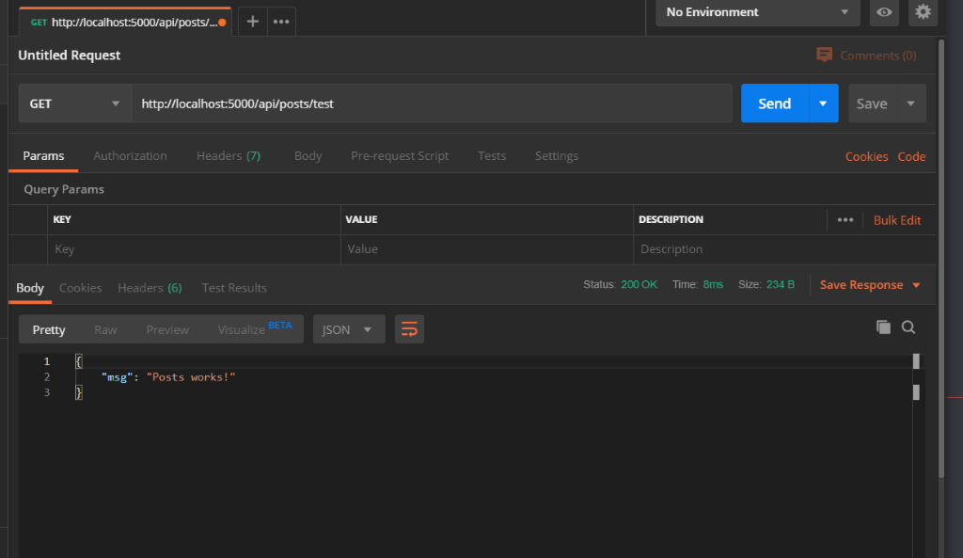

**api/posts/like/id (POST)**

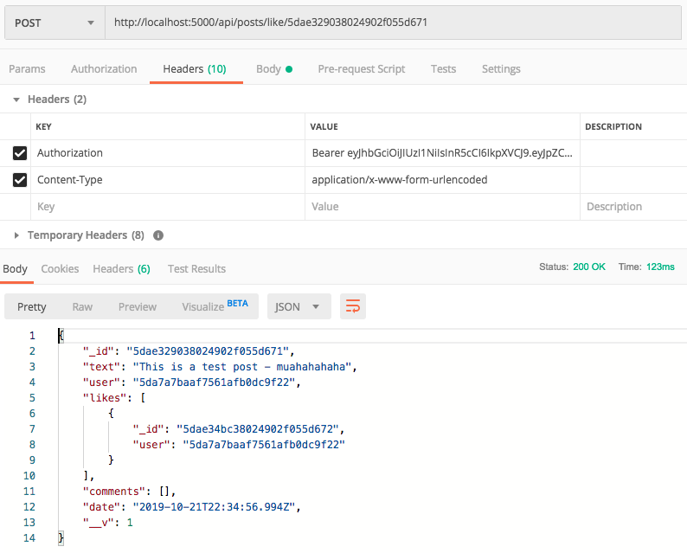

**api/posts/id (DELETE)**

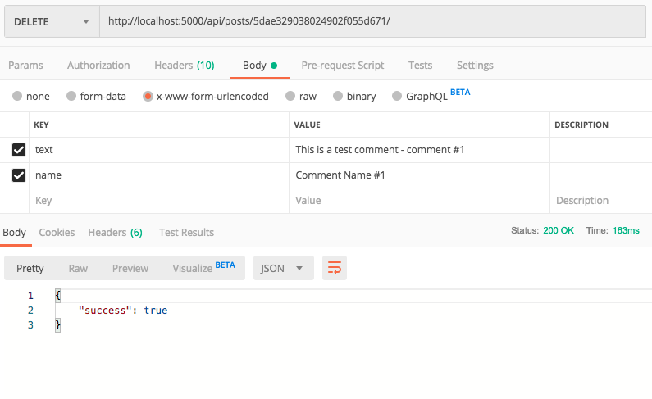

**api/posts/id (GET)**

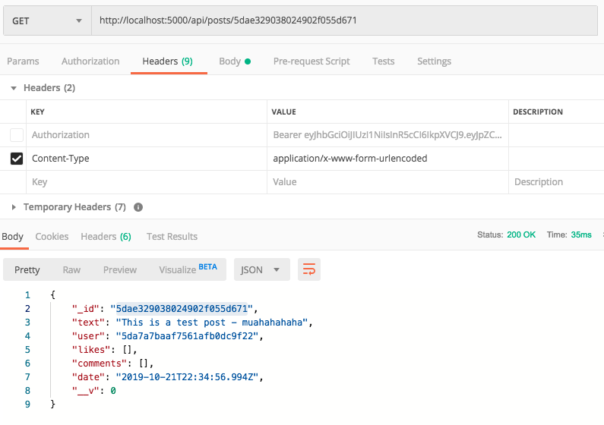

**api/posts (GET)**

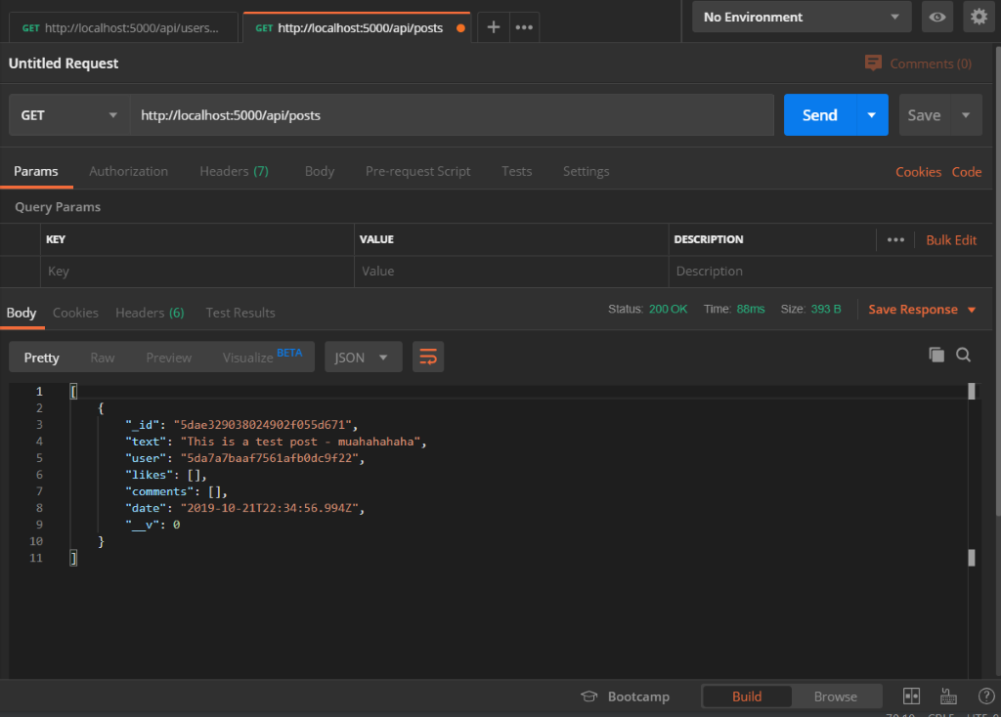

**api/posts/comment/id (POST)**

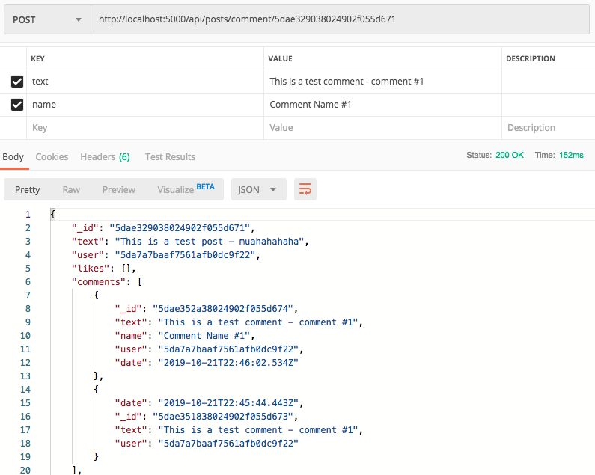

**api/posts/comment/id (POST)**

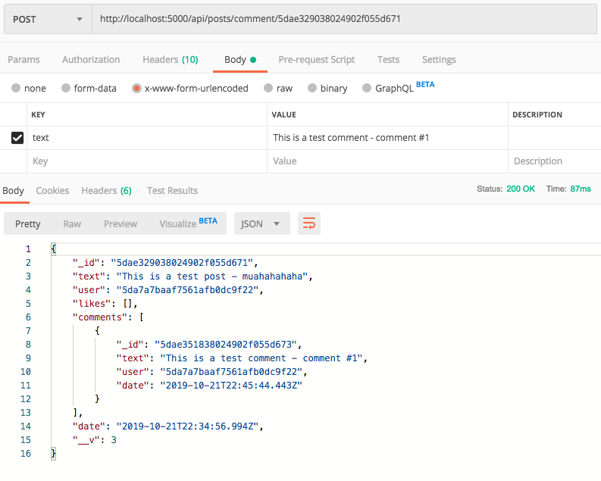

**api/posts (POST)**

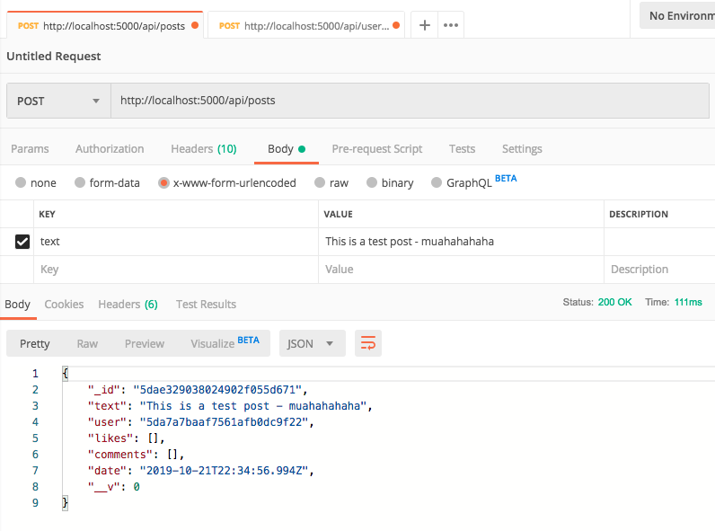

# Intellectual Property Agreement





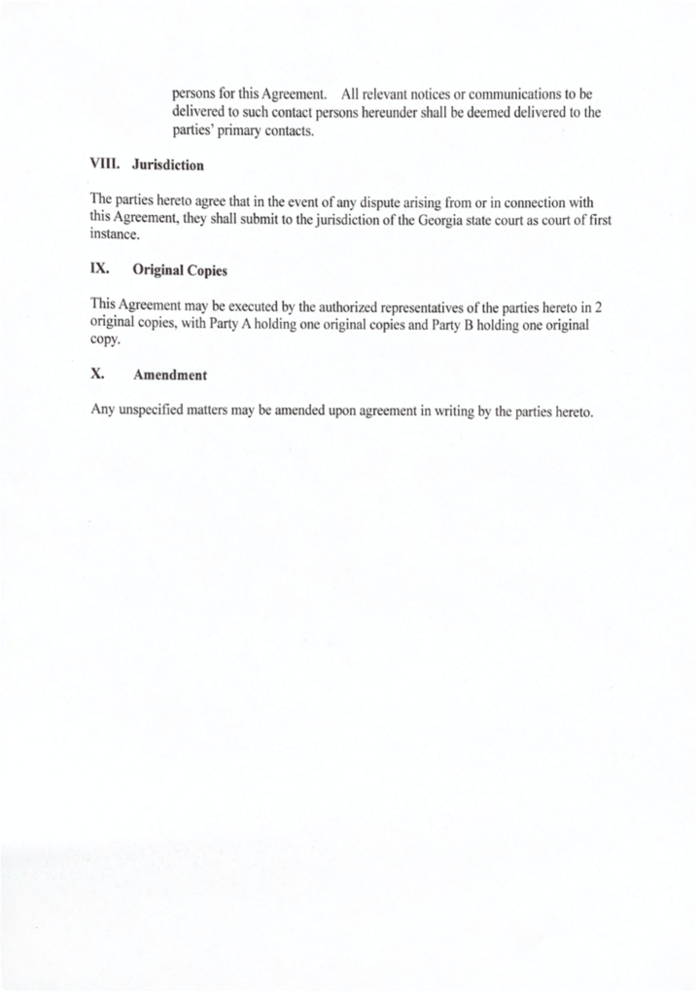

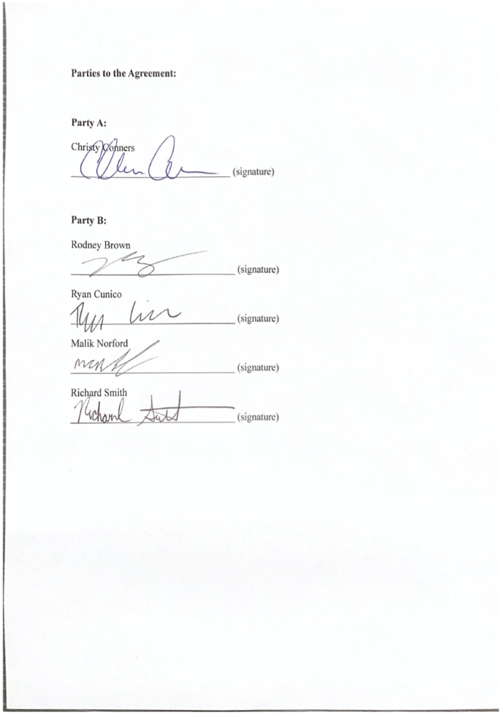

# Installation, User, and Development Documentation

Requirements, IP agreement, Client Notes, and Presentations are located in the doc folder in the ShutterPlug repository:

**https://github.com/GGC-SD/ShutterPlug/tree/master/doc**

User installation / access instructions are located in README.md:

**https://github.com/GGC-SD/ShutterPlug/blob/master/README.md**

API Routes are located in the doc folder in the ShutterPlug repository:

**https://github.com/GGC-SD/ShutterPlug/tree/master/doc**

The working Shutter Plug web application can be accessed directly at the following URL:

**https://shutterplug.herokuapp.com/**

# Development Information

**Gmail:**

https://mail.google.com/

**MongoDB: Database**

https://cloud.mongodb.com/

**Heroku: Cloud Platform for Web Deployment**

https://www.heroku.com/

**YouTube:**

https://www.youtube.com/

# Usability Testing / Focus Group Survey Results

The following charts summarize the survey results from the 2019 CREATE presentation.

**Appearance, Usefulness, and Completeness - Sums**

**Appearance, Usefulness, and Completeness – Individual Totals**

